The European Union

Vocabulary: flag, countries, anthem, history, stars, money
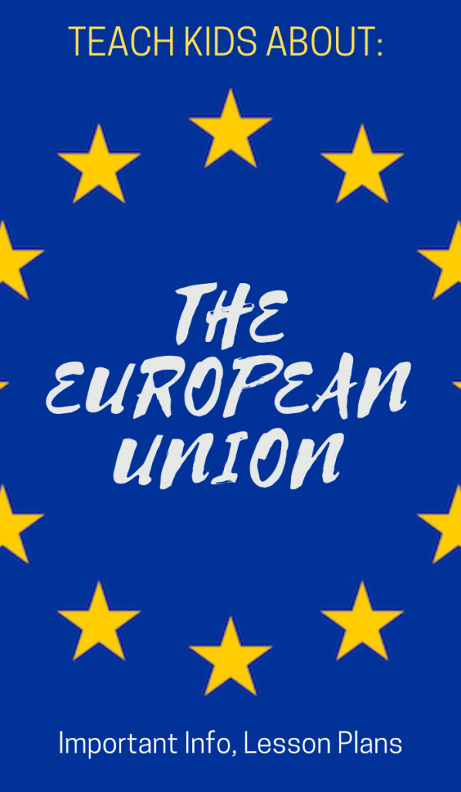
Countries

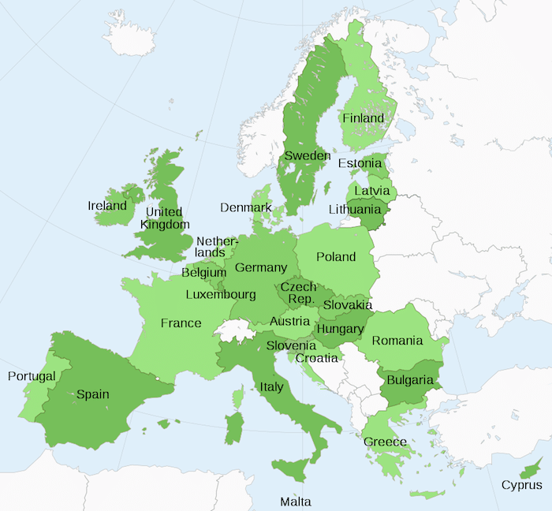

Parliament

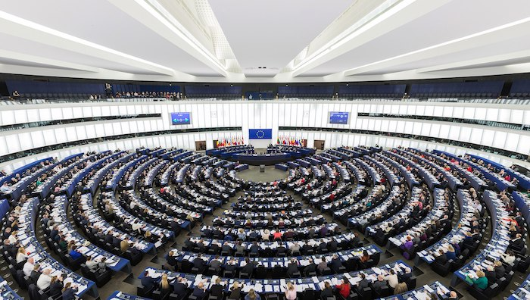

Money

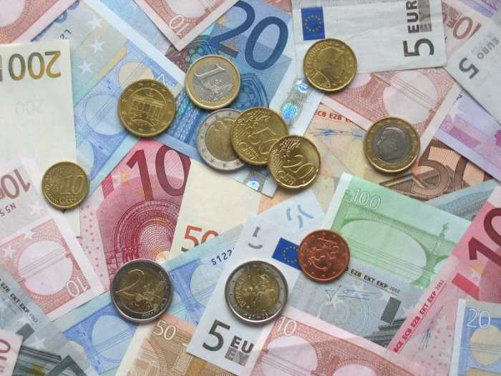

Flag

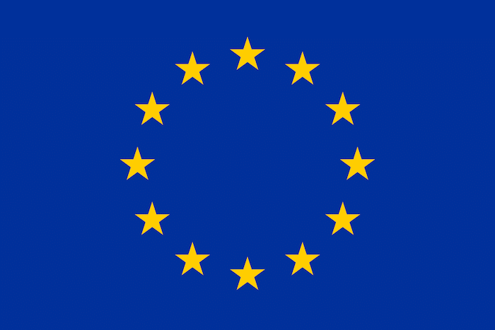

Video
https://www.youtube.com/watch?v=XxutY7ss1v4
https://kidworldcitizen.org/how-to-teach-kids-about-the-european-union/
Anthem
https://www.youtube.com/watch?v=Jo_-KoBiBG0

